### **Math’s Hidden Groove: The Secret Sauce of Synthesis**

### **By someone who’s patched sine into chaos, dropped thai curry over whitepapers, and thinks Abelian groups are secretly funky.**

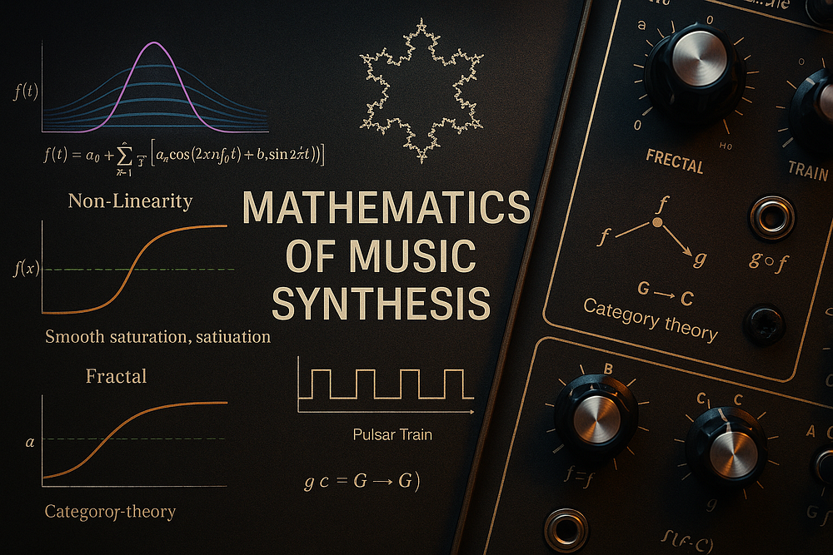

Prelude: Where Patch Cables Meet Proofs

Hey friends! Picture this: it’s 3:17 AM, your modular synth looks like a spaghetti monster with a pension plan, and you’ve just discovered that plugging the VCO sqr ouput back into into filter cutoff and tweaking the resonance just to perfection makes the clouds part and angels sing (but with p o w e r — srsly, try it — it produces formants!) That moment — when randomness forms rhythm, when noise turns to nuance — that’s not just good luck or golden ears. That, dear reader, is math winking at you from behind a sine wave.

As the self-appointed math roadie for RYO Modular and wielder of both Rust and ribbon cables, I’ve long suspected that behind every glorious wobble or crunchy bite, there’s a number in disguise. Beneath the voltage lies the vector. Under the synth lies the symphony of structures. So let’s talk about that — not in dry, chalky terms, but like two geeks in a synth cave passing patch cords and stories.

We’re about to explore how **Fourier series**, **non-linearities**, **fractals**, and **category theory** all conspire to turn oscillators into orchestras. Think of it as a backstage tour of synthesis with mathematics as the stagehand pulling all the levers. You’ll get clean diagrams, spicy metaphors, and maybe a few belly laughs. No proof-heavy lectures — just a late-night curry-fueled brainstorm about how math sings.

#### **I. Waves of Wonder: Fourier Series and the Sonic Smoothie**

Let’s start at the core: **Fourier series**. It’s the mathy idea that *any periodic waveform* can be expressed as a sum of sine waves. Take a square wave — it’s not some alien construct. It’s just an infinite series of odd harmonics stacked just right:

The fourier series equation

Like turning a chord into its individual notes, this decomposition is music theory for voltage. It’s also the math behind additive synthesis, spectral filtering, and even your DAW’s EQ analyzer.

courtesy of wikimedia commons

> *”The square wave is just a sine wave with delusions of grandeur.”*

In software synthesis, this is your bread and butter. Need a sawtooth? Sum those harmonics. Want to simulate the slow attack of a bowed cello? Shape the envelope of each harmonic. Fourier gives you Lego bricks made of sine, and every sound is just a new build.

But here’s the wild bit: *Fourier series get fractal*. Zoom in on partial sums approximating a square wave — notice those ripples near the edges? That’s **Gibbs phenomenon**. Even pure math can’t escape a bit of distortion.

#### **II. The Grit Factor: Non-Linearities and Why Perfect Is Boring**

Linear math gives us predictability. But *non-linearity* gives us soul. A diode doesn’t say, “Sure, come on in.” It says, “You’re welcome — if you’re loud enough.”

Non-linearities are those lovely little rule-breakers:  
- Clipping circuits = harmonic distortion.  
- Saturating inductors = asymmetry and lag.  
- Soft limits = analog warmth that you can *feel*.

> Try feeding a clean sine into a wavefolder. What comes out is math in rebellion.

The Sigmoid or Tanh — Curves With Character  
Equation:

equation for the non-linear curve f(x) = tanh(x)

**Why This One?**  
The hyperbolic tangent (tanh) is smooth, squishy, and saturates gently. It models how some analog components (like transistors or vacuum tubes) respond: linear-ish in the middle, flat at the ends.

Think of it as:  
- A soft waveshaper  
- A transfer function of a diode clipper  
- A smoothed approximation of hard clipping

**Synth Patch Analogy:**

Imagine:  
Sine Oscillator → tanh() → Output

You feed in a clean sine, and tanh() adds harmonic distortion by gently compressing the peaks — a soft-clipping overdrive that fattens the signal without harshness.

- Mathematically: it’s a non-linear transformation of the waveform.  
- Psychoacoustically: it’s creamy analog warmth, baby.

Mathematically, these bends are functions where output doesn’t scale cleanly with input. Think tanh(x), sigmoid curves, or even chaotic feedback loops. Their derivatives misbehave, and that’s *exactly* why we love them. They breed *new frequencies* — the sidebands, the grit, the growl.

Here’s what happens when you apply increasingly non-linear functions to a waveform:

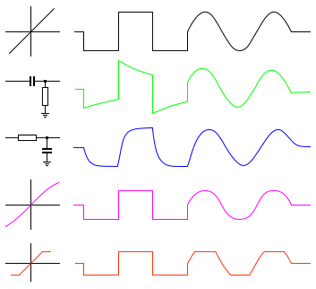courtesy of wikimedia commons

In synthesis, these curves *create content*, not just shape it. They are to sound what spices are to cooking — intensity, texture, character. You can synthesize a violin, but until you model the chaotic non-linear behavior of wood and rosin? It’ll never sing.

#### **III. Infinite Echoes: Fractals in Sound**

You know what’s cooler than random noise? *Structured randomness*. Enter: **fractals**. These aren’t just pretty math posters — they’re the pulse of nature’s rhythms.

Fractals are defined by **self-similarity** — zoom in and you find the same pattern, again and again. In music, that’s:  
- **Rhythmic subdivisions** (like Euclidean rhythms)  
- **Granular synthesis** (micro-loops nested inside macro-loops)  
- **1/f noise** (a.k.a. pink noise — natural, textured, organic)

> White noise is chaos. Pink noise is a memory.

2. Fractals: The Logistic Map — Chaos From Simplicity  
Equation:

The Logistic Map: Chaos From Simplicity — A Basic Fractal Equation

Where:



and

𝑟 controls how chaotic the output gets (around 3.57 and above → chaos)

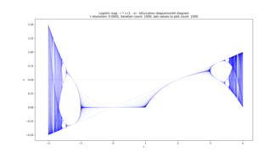courtesy of wikimedia commons

Why This One?  
This is the logistic map, a classic in chaos theory. It models population growth… and also sounds that evolve with unpredictable-yet-patterned behavior. It’s simple, recursive, and leads to rich, fractal behavior.

Synth Patch Analogy:  
Use x_n as a modulation source for filter cutoff, pitch, or wavefolding.

Control Loop:  
 x[n+1] = r * x[n] * (1 - x[n])  
 x[n+1] → VCF Cutoff

If you let this modulate a filter:  
- Low r = smooth LFO  
- High r = glitchy, pseudo-random pulses with fractal-like zoomed structure

It’s a fractal LFO in disguise.  
Self-similar and evolving — a natural fit for drones, generative patches, or granular stuff.

Here’s a visual from Wikipedia’s cosmic microwave background radiation article — it’s basically a 1/f noise eqn that turns out to be — yup, self similar as it scales own/up:

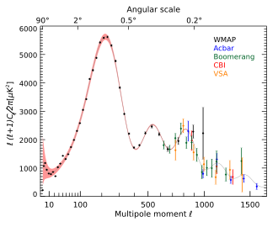The power spectrum of the measured [cosmic microwave background radiation](https://en.wikipedia.org/wiki/Cosmic_microwave_background_radiation) temperature anisotropy in terms of the angular scale. The solid line is a theoretical model, for comparison. image courtesy of wikimedia commons

In your patches, fractals let simple systems bloom. Use feedback with slight delay changes. Layer LFOs at prime ratios. Iterate with subtle variation. Suddenly, a simple idea becomes an ambient wash that evolves for hours — *structure from recursion*.

I’ve even used fractals in SDR synths to mimic biological rhythms — heartbeats, breath, cosmic microwave background. You name it. Why? Because nature *is* fractal. So synthesis should be too, perhaps?

#### **IV. The Hidden Web: Category Theory and the Architecture of Sound**

Okay, now we get spicy.

**Category theory** is math’s meta-language. Instead of numbers, it deals with **objects** and **morphisms** (arrows) — ways things transform. In synthesis terms:  
- Oscillators, filters, envelopes = *objects*  
- Patch cables = *morphisms*  
- The *composition of modules*? That’s a functor, baby.

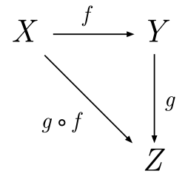Schematic representation of three objects and three morphisms of a category, which form a commutative diagram image courtesy of wikimedia commons

3. Category Theory: A Patch As a Composition of Morphisms  
Equation (In Category-Speak):

𝑓:𝐴→𝐵, 𝑔:𝐵→𝐶 ⇒ 𝑔∘𝑓:𝐴→𝐶

Where:

- A, B, C = modules/types of signal  
- f, g = processes (morphisms)  
- g ∘ f = means “do f, then g”

Why This One?  
This expresses composition — the soul of patching. If f is your VCO → VCF, and g is VCF → VCA, then chaining them is just:

f = VCO → VCF  
g = VCF → VCA  
g ∘ f = VCO → VCF → VCA

Synth Patch Analogy (Abstracted Patch View):  
A: VCO signal  
B: Filtered signal  
C: Amplitude-controlled output

f: filter(signal) = VCF  
g: amplify(signal) = VCA

Patch:  
 A — f → B — g → C

In category theory terms, this is the compositional structure that defines a signal chain. Functors map entire patches between systems (e.g. from analog to digital domain), natural transformations connect similar patches under different implementations, etc.

Category theory helps you reason about structure, not just data flow.  
In synthland: it’s the ultimate abstraction of patching logic.

This view is more than cute abstraction. It helps:  
- Design modular synths as **composable systems**  
- Build reusable patches with **function pipelines**  
- Understand feedback and recursion structurally

In category theory, you don’t ask “What is this module doing?” You ask “How does this relate to others?” It’s network thinking — the exact mindset that makes modular synths so powerful. It even underpins functional programming languages like Haskell, which is basically musical Lego for software devs.

> *Category theory is just patch cables without the rack.*

#### **V. Coda: Let the Math Sing**

So, what do you get when you blend:  
- **Fourier’s smooth serenades**  
- **Non-linear distortion’s grit and growl**  
- **Fractal recursion’s infinite texture**  
- **Category theory’s structural poetry**?

You get synthesis: the mathematical art of sound.

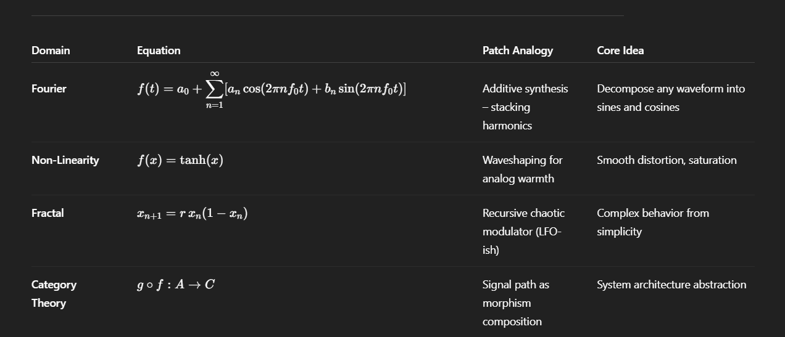Summary Table: Domains to be discussed in this series.

Math isn’t just the backend. It *is* the frontman, the drummer, the ghost in the machine. From partial differential equations to chaotic attractors, from phase space folding to mono functor morphisms, the more you understand the structure, the wilder the patch you can dream.

Next time you’re elbow-deep in patch cables, ask: What would Fourier say? What curve would *f(x)* fold? What echo lives in that LFO?

And then chase it. Because the beauty of synthesis isn’t just hearing the sound — it’s *seeing the shape* behind it.

### **Resources**

**Fourier Series**:  
- <https://en.wikipedia.org/wiki/Fourier_series>- <https://en.wikipedia.org/wiki/File:Fourier_series_square_wave_circles_animation.gif>

**Non-linearities**:  
- <https://ccrma.stanford.edu/~jos/wshaper/>- <https://ccrma.stanford.edu/~jos/pasp/Wave_Digital_Filters.html>

**Fractals & Noise**:  
- <https://en.wikipedia.org/wiki/Colored_noise>- <https://en.wikipedia.org/wiki/Fractal>

**Category Theory**:  
- <https://math3ma.com/categories>- <https://github.com/hmemcpy/milewski-ctfp-pdf>